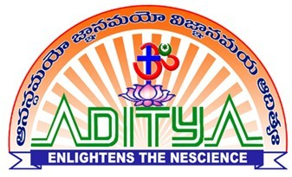 ADITYA COLLEGE OF ENGINEERING :: SURAMPALEM

FACULTY PROFILE

**Personal Profile Name** N JASWANTH

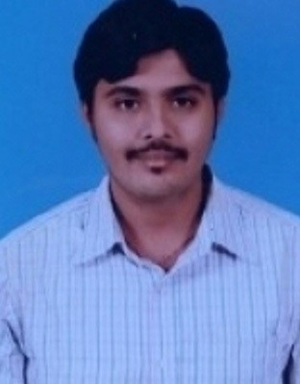

**Date of Birth** 23-03-1992

**Address** Department of EEE,

Aditya College of Engineering, Surampalem-533437

East Godavari District, Andhra Pradesh

**Date of Joining** 05-06-2021

|  |  |
| --- | --- |
| **Vidwan profile** | https://vidwan.inflibnet.ac.in/profile/382709 |

Academic Profile

|  |  |  |
| --- | --- | --- |
| **Qualification** | **Name of the Board/University** | **Year of Passing** |
| B.Tech | ADITYA ENGINEERING COLLEGE | 2013 |
| M.Tech. | HELAPURI Inst. Of Tech and Science | 2016 |
| Ph.D. |  |  |
| Others |  |  |

Professional Experience

|  |  |  |
| --- | --- | --- |
| **Designation** | **Name of the Employer** | **Length of Service** |
|  | Aditya College of Engineering | Till Date |

Life long membership in MISTE

**Memberships of Professional Societies:**

Research Publications

|  |  |  |  |  |  |
| --- | --- | --- | --- | --- | --- |
| **National**  **Conference** | **International**  **Conference** | **National**  **Journals** | **International**  **Journals** | **Books / Book**  **Chapters** | **Patents** |
|  |  |  |  |  |  |

Seminars/ Workshop/ FDPs attended

|  |  |  |
| --- | --- | --- |
| **Seminars** | **Workshops** | **FDPs** |
| 4 | 2 | 2 |

NPTEL FDPs / Professional Certification

|  |  |  |  |
| --- | --- | --- | --- |
| **NPTEL** | **Coursera** | **Udemy** | **Others** |
|  | 1 |  |  |

Other Information

2)

1)